**TRIBHUWAN UNIVERSITY**

**INSTITUTE OF SCIENCE AND TECHNOLOGY**

BIRENDRA MULTIPLE CAMPUS



A final year project on

**“Refone Store”**

A final year project report submitted in partial fulfillment of the requirement for the degree of Bachelor of Science in Computer Science and Information Technology awarded by Tribhuwan University.

**Submitted by:**

Samundra Khanal (21707/075)

Tufan Bhandari (21724/075)

Prabesh Mishra (21686/075)

**Submitted to:**

**Birendra Multiple Campus**

Department of Computer Science and Information Technology

Bharatpur-10, Chitwan

**SUPERVISOR’S RECOMMENDATION**

I hereby recommend that this project prepared under my supervision by Samundra Khanal (21707/075), Tufan Bhandari (21724/075) and Prabesh Mishra (21686/075) entitled **“Refone Store”** in partial fulfillment of the requirement for the Degree of Bachelor in Computer Science and Information Technology be processed for the evaluation.

……………………

**Mr. Binod Sharma**

HOD, Department of BSc. CSIT

Birendra Multiple Campus

Bharatpur-10, Chitwan

**CERTIFICATE OF APPROVAL**

This is to certify that this project prepared by Samundra Khanal (21707/075), Tufan Bhandari (21724/075) and Prabesh Mishra (21686/075) entitled **“Refone Store”** in partial fulfillment of the requirement for the Degree of Bachelor in Computer Science and Information Technology has been well studied. In our opinion, it is satisfactory in the scope and quality as a project for the required degree.

|  |  |
| --- | --- |
| Signature of the Project Supervisor  ……………………..  **Mr. Binod Sharma**  HOD, Department of CSIT  Birendra Multiple Campus | Signature of the HOD/Coordinator  …………………..  **Mr. Binod­ Sharma**  HOD, Department of CSIT  Birendra Multiple Campus |
| Signature of External Examiner  ……………………… | Signature of Internal Examiner  …………………… |

**ACKNOWLEDGEMENT**

Working in the team of three had made us realize that teamwork can be of great asset in accomplishing a mission. We learned many things as a team as well as individuals while working on this project. This project is developed regarding the consent of fulfilling the partial requirement indexed by Tribhuvan University for the completion of Bachelor in Computer Science and Information Technology (Bsc.CSIT) seventh semester. We are very delighted and it was our great pleasure to have the opportunity to extend our heartfelt gratitude to every individual who guided in completion of our project. We are very much thankful and grateful to our project manager **Mr. Binod Sharma** for providing us help, guidance, continuous encouragement and ever willingness to spare time from his otherwise busy schedule for the project's review. Continuous monitoring in our project by taking certain instances from his work schedule has made the project successful.

Our team would also like to thank our supervisor **Mr. Binod Sharma** for his unconditional support and continuous motivation as well as supervision on our project and made our project successful. We would also like to show our gratitude to all the faculty members as well as fellow classmates for the continuous support and creating a suitable working environment.

**ABSTRACT**

**Refone Store** is a second-hand smartphone selling application that allows users to sell and buy second-hand smartphones. It has features like smartphones categorization based on brands, smartphone search by name, price, features and geo-location map to the nearest smartphone store, and exclusive analysis feature for the smartphone picture to get its details.

This application has been developed using Android Studio as an IDE, Kotlin as the programming language, XML as defining layout, android built in layout editor to design the layout and backend part using the firebase. It aims to provide convenience and useful features to their respective user bases. It also includes a feature for users to create wish lists and get notifications when a desired smartphone becomes available for purchase.

This application also ensures the user’s privacy in terms of making smartphones and geo location coordinates available to the application.

Keywords: *Phone Store, Android, Application, Kotlin, Firebase*

CONTENTS

Chapter 1: Introduction 1

1.1 Introduction 1

1.2 Problem Statement 1

1.3 Objectives 2

1.4 Scope and Limitation 3

1.4.1 Scope 3

1.4.2 Limitations 3

1.5 Development Methodology 4

1.6 Report Organization 5

Chapter 2: Background Study and Literature Review 6

2.1. Background Study 6

2.2. Literature Review 7

Chapter 3: System Analysis 8

3.1. Requirement Analysis 8

3.1.1. Functional Requirements 8

3.1.2. Non-functional Requirements 10

3.2. Feasibility Study 10

3.2.1. Technical Feasibility 11

3.2.2. Operational Feasibility 11

3.2.3. Economic Feasibility 11

3.2.4. Schedule Feasibility 11

3.3. Analysis 12

3.3.1. Data Modeling using ER-Diagram 12

3.3.2. Process Modeling using DFD 13

Chapter 4: System Design 16

4.1. Design 16

4.1.1. Database Design 17

4.1.2. Interface and Dialogue Design 18

4.1.3. Form and Report Design 18

4.2. Algorithm Details 18

Chapter 5: Implementation and Testing 19

5.1. Implementation 19

5.1.1. Tools Used 19

5.1.2. Technology Used 20

5.1.3. Database 21

5.1.5. Implementation Details of Modules 21

5.2. Testing 22

5.2.1. Unit Testing 22

5.2.2. System Testing: 26

5.3. Result Analysis 26

5.3.1. Challenges Faced: 27

5.4. Significant Features 27

Chapter 6: Conclusion and Future Recommendations 28

6.1. Conclusion 28

6.2. Future Work: 29

References 30

APPENDIX 31

**LIST OF ABBREVATIONS**

**SQL:** Structured Query Language

**DFD**: Data Flow Diagram

**ER:** Entity Relationship

**SDK:** Software Development Kit

**IDE**: Integrated Development Environment

**UI:** User Interface

**QA:** Quality Assurance

**AVD**: Android Virtual Device

**XML**: Extensible Markup Language

**GUI:** Graphical User Interface

**SDLC**: Software Development Life Cycle

**UK:** United Kingdom

**LIST OF FIGURES**

Figure 1: Development Methodology (Waterfall Model) 4

Figure 2: Use case Diagram 9

Figure 3: Gantt Chart for Application Development 12

Figure 4: ER-Diagram 13

Figure 5: Level 0 DFD 14

Figure 6: Level 1 DFD 14

Figure 7: Level 2 DFD (View Products) 15

Figure 8: Level-2 DFD (Report Generate) 15

Figure 9: System Structure of our Application 16

Figure 10: Database Schema Diagram 17

Figure 11: Block Diagram of this application with database 21

Figure 12: App Loading Page 31

Figure 13: Create an Account Page 31

Figure 14: Login Page 32

Figure 15: Forgot Password Page 32

Figure 16: Dashboard Page 33

Figure 17: Products Detail Page 33

Figure 18: Product Search Page 34

Figure 19: My Products Page 34

Figure 20: Add Products Page 35

Figure 21: My Orders Page (Bought) 35

Figure 22: My Order Details Page (Seller) 36

Figure 23: Sold Products Page (Seller) 36

Figure 24: Sold Product Details Page (Seller) 37

Figure 25: Sold Products Page (Seller) 37

Figure 26: User Account Page 38

Figure 27: Edit Profile Page 38

Figure 28: Product Details Page (Buyer) 39

Figure 29: My Cart Page (Buyer) 39

Figure 30: Add Address Page (Buyer) 40

Figure 31: Checkout Page (Buyer) 40

**LIST OF TABLES**

Table 1: Testing Registration System (Case-1) 22

Table 2: Testing Registration System (Case-2) 23

Table 3: Testing Login System (Case-1) 23

Table 4: Testing Login System (Case-2) 24

Table 5: Testing Search Products 24

Table 6: Testing Filter Products 24

Table 7: Testing to add Products in Cart List 25

Table 8: Testing to Manage Order Details 25

Table 9: Testing Reset Password 25

Table 10: System Testing 26

# Chapter 1: Introduction

## 1.1 Introduction

Welcome to **Refone Store**, an online application for buying and selling second-hand smartphones was built in hope for it to be beneficial for the customers who can’t find time to visit the store for purchasing smartphones. This application is a platform where users can buy used smartphones. It offers a convenient and easy way for people to purchase used devices at a more affordable price than buying a brand new one.

With the increasing cost of new smartphones, many users refer second-hand phones to find a cost effective solutions. However, finding reliable and trustworthy sources can be a challenging task. This is where **Refone Store** comes in, offering a seamless and user-friendly interface that enables buyers to easily search and find the devices they need, while sellers can list their items and reach a wider audience.

## 1.2 Problem Statement

In today’s digital age, smartphones have become an essential part of our lives. With the increasing numbers of mobile phones available in the market it can be overwhelming especially for those who can’t afford new ones, to make the right choice. Moreover, with the rise of e-commerce, buying a smartphone has become even more complex, as users are bombarded with options from different brands, sellers, and price ranges.

To simplify the smartphone buying process for general public, we aimed to develop a smartphone buying application that provides a user-friendly interface and comprehensive information about various smartphones available in the second-hand market. The application should allow users to search, compare and select smartphones based on their preferences, such as price range, brands, operating systems, camera quality, battery life and other important features.

To enhance the user experience and facilitate them with enough products, we planned to connect our application with the local smartphone store. These stores will receive proper training on how to sell their smartphones through this platform and make available to all users who are willing to buy a second-hand smartphone.

In addition to providing a platform for second-hand smartphone sales, this application aims to promote sustainability and reduce waste created from unused and old smartphones. Rather than letting the smartphones degrade users can sell their used phones and give them a new life with another users. This not only benefits the environment but also provides affordable access to those who may not be able to afford brand new smartphones. By facilitating the circulation of old smartphones direct from home it helps save time of buyers as well as sellers so they can utilize their time in different other productive works.

## 1.3 Objectives

The major objectives of this applications are mentioned below:

* Increased and easy access of smartphones to the local users: Users who don’t have any knowledge about the availability of smartphones in their local areas can use this application to buy smartphones easily that are available locally.
* Community engagement: As our application will be connected with the local smartphone store, it can help tech enthusiasts to know more about the emerging smartphone technologies in their locality as well as in their country.
* Easy Buy and Sell of Smartphones: After development of our application, we make sure that the sellers who want to sell their smartphones will be able to easily add their products in the online market and the buyers will be able to purchase the available smartphones in the online store easily.

## 1.4 Scope and Limitation

### 1.4.1 Scope

**Refone Store** is an android mobile application suitable for all the smartphone owners. Specially, it is designed to facilitate the smartphone owners who want to sell their used smartphones and for the new smartphone users who wants to buy those used phones. Users having an android smartphone can easily install and use this application. This application is very easy to use and simple to understand as it will have a user-friendly interface, search functionality and able to purchase selected smartphones. So, the smartphone sellers will definitely want to have this application in their smartphone installed. This application would create a database which would act as a backup of all the data of the sold smartphones for the sellers and purchased phones for the buyers.

### 1.4.2 Limitations

Although we have tried our best to create a fully functional and user-friendly app, due to the limited time constraint of the project, there are still a few gaps in our application. Some of them are:

* This app will only be available in the Android platform initially.
* This application works only with the active internet connection.
* This app does not verify the quality of the smartphones being sold or purchased.
* Must require android version 5.0 and above.
* Application users must know English Language.

## 1.5 Development Methodology

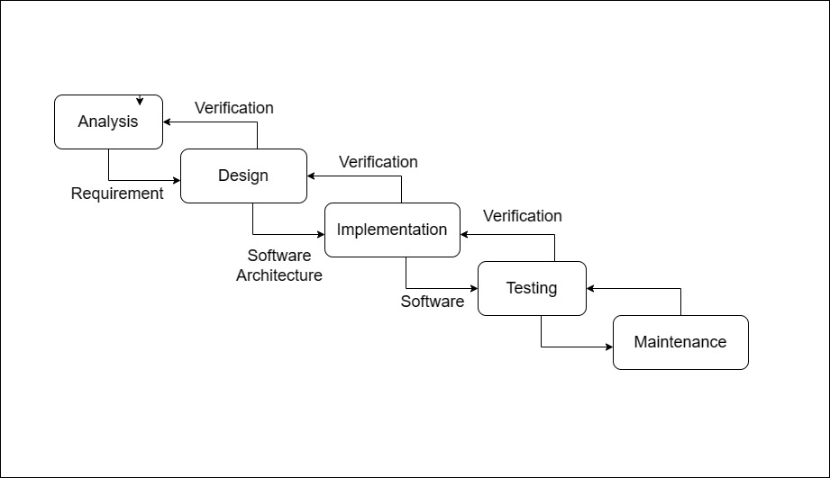

**Figure 1: Development Methodology (Waterfall Model)**

**Waterfall Methodology**

The Waterfall Methodology is a traditional and most used approach by software and products development teams to manage their project. It follows a linear, sequential flow of different activities. It contains a set of distinct phases, such as planning, analysis, design, implementation, testing, deployment and maintenance, where each stage must be completed before moving on to the next.

In the Waterfall approach, project requirement was fixed at the outset, and any changes to the scope was not allowed during the development phase. The methodology assumes that the requirements are fully understood and can be clearly defined before the development phase begins. This methodology was well suited for our project types with well-defined requirements and where the deliverables are predetermined.

## 1.6 Report Organization

The project is divided into six distinctive chapters where each of them define a different development phase. The brief discussion on the chapters is given below:

**Chapter 1** provides an introduction about the project, its objectives, purposes, scope and limitations. It outlines how the project is planned to accomplish its goal and objectives aligning to its idea and how it was developed.

**Chapter 2** is more diverted towards the prior preparations and research before heading towards the project initiation and planning. It consists of background study and literature review which is more than necessary to know about the current scenario on similar projects and improving on the current working project.

**Chapter 3** is all about the analysis and requirement of this project. It consists of the feasibility study performed to determine the feasibility of this project. This chapter also visualized the process and entities in the project with the help of ER and DFDs.

**Chapter 4** discusses how the required system is designed based on the project idea which includes the design of the process, databases, layouts, interfaces and reports.

**Chapter 5** deals with the implementation of the designed system and testing of the developed system. It consists of various tools and techniques used for the project development as well as testing.

**Chapter 6** finally put an end to the process of the project presenting the conclusion. It highlights the conclusive points for this project and the future changes to be done for the improvement of the project.

# Chapter 2: Background Study and Literature Review

## 2.1. Background Study

The second-hand smartphone market has seen a resurgence in recent years, with many consumers opting to buy used smartphones rather than a new phone. This trend can be attributed to several factors, including the rising cost of new smartphones, the desire for sustainability, and the unique charms of used books. As a result, the market for second-hand smartphone selling application has grown significantly, with many apps available in the market. It is reasonable to say that the process of buying mobile phones through the applications online has become a commonplace.

The objective of this project is to develop a general-purpose application where second-hand smartphones can be bought from the comfort of home through the Internet. An online smartphone store is a virtual store on the Internet where customers can browse the available products and select smartphones of interest. The selected items may be collected in a shopping cart. At checkout time, the items in the shopping cart will be presented as an order. At that time, more information will be needed to complete the transaction including the names, address and contact number of the product receivers.

In addition to the features offered by existing applications, it is important to analyze the market dynamics of the second-hand smartphone marketplace. This includes a study of the buying behavior of the consumers, product most often bought, the demographics of smartphone buyers, and the competitive landscape of the market. By understanding these factors, the **Refone Store** team has identified the potential demand for a second-hand smartphone selling supplication and develop a targeted marketing strategy to reach out to the potential users or consumers.

## 2.2. Literature Review

The concept of second-hand smartphone selling is not a new and has been around the centuries. In recent times, the rise of the internet and smartphone technologies had led to the increasing number of use of smartphones and hence these demanded for the platforms to sell and buy smartphones. These platform offers a convenient and cost-effective way for buyers and sellers to connect with each other and perform transactions for smartphones.

A study by SellCell in 2021 found that over 80% of US consumers surveyed were willing to buy a used mobile phone [1]. Several companies have emerged in recent years that specialize in the resale of used mobile phones, such as Gazelle, Swappa and Decluttr. These companies typically purchase used phones from individuals and refurbish them for resale. A study by the University of Cambridge [2] in 2020 found that these companies can contribute to a more circular economy by extending the lifespan of mobile devices and reducing electronic waste.

The second-hand mobile device market is expected to continue growing in the coming years, with some estimates suggesting that it could reach $67 billion by 2024. This growth is driven by factors such as rising demand of affordable smartphones, increased awareness of environmental issues, and improvements in the quality of refurbished devices.

Despite the growing popularity of second-hand mobile devices, some consumers may have concerns about the quality and reliability of these devices. A study by the International Association of Information Technology Asset Managers [3] in 2019 found that 46% of consumers surveyed were concerned about buying used mobile due to fears of malware or other security issues.

Overall, the literature suggests that the second-hand mobile device market is growing rapidly and that there is significant consumer interest in buying used smartphones.

# Chapter 3: System Analysis

## 3.1. Requirement Analysis

Requirement analysis is the process of precisely identifying, defining and documenting the various requirements that are required for the development of the project and product. This process involves gathering and analyzing information from a variety of sources, including stakeholders, customers, industry, experts and other related parties. Requirement gathering helps in clearly understanding the needs of the customer, defining the scope of the project, and assessing the timeless and resources required to complete it. There are two types of requirements which are as follows:

* Functional Requirement
* Non-Functional Requirement

### 3.1.1. Functional Requirements

In order to make the application functional, we require the following:

1. **User Registration**: Given that a user has downloaded the mobile application, then the user must be able to register through this mobile application. The user must provide username, email, mobile number and password.
2. **User login**: After the user has registered, then the user should be able to log in to the application through the email and password. The login information will be stored on the phone and in the future the user should be logged in automatically.
3. **Reset Password**: Given that the user has registered, then the user should be able to reset his/her password through the email in case the password is forgotten.
4. **Search and browse**: Users should be able to search for and browse books by title, author, and other relevant criteria, and filter the results to narrow down their options.
5. **Add smartphones for sale**: Users should be able to list their phones for sale on the application, including information such as the Brand name, model number, features, condition and price range.
6. **Owner Profile**: The user should be able to view their own profiles, modify their details, change password, emails and photos.
7. **Add to cart**: The buyers must be able to add the products to their cart and proceed for the purchase of the products.
8. **Logout**: The user must be able to logout of the application.

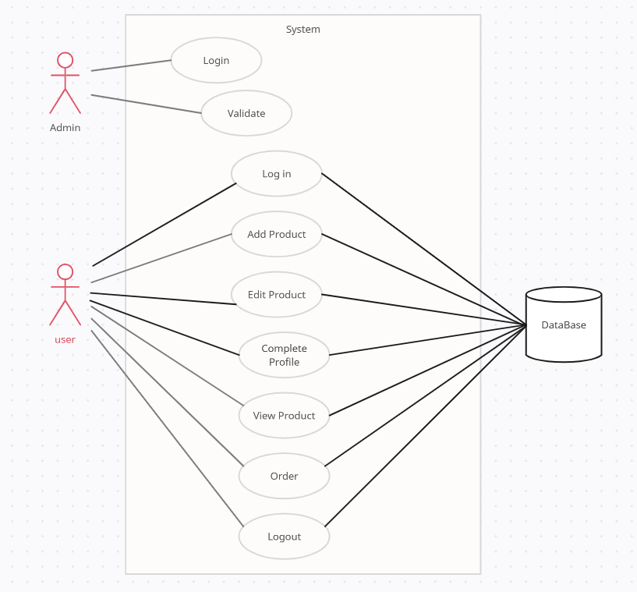

**Figure 2: Use case Diagram**

The above use case diagram also shows the functional requirement of the application. A use case diagram is a graphical depiction of the interactions among the elements of a system. It is used in system analysis to identify, clarify, and organize system requirements.

### 3.1.2. Non-functional Requirements

The non-functional requirement of this mobile application are as follows:

1. **Performance**: The performance requirements provide a detailed specification of the user interaction with the application and measurements placed on the application performance. For the response time, it should not be more than 5 sec if the users have a proper internet connection and for the fault tolerance, if the system loses internet connection or the systems gets some strange input, the user should be informed.
2. **Maintainability**: The application is be easy to extend. The code should be written in a way that it favors implementation of new functions. In addition to this, test environment is built for the application to allow testing of the different functions.
3. **Look and Feel**: The user interface is light and easy. The bright color and multiple color theme are discarded. The user is also informed correctly if he/she is doing anything wrong.
4. **Availability**: The application is available 24/7. The machine learning module was hosted on Firebase Cloud service with 24/7 uptime and other modules are hosted on same Firebase hosting service ensures 99% uptime.
5. **Reliability**: This system has automatic backup system and also crash monitoring and informing system. It is reliable and works as intended by the developer.
6. **Scalability**: Since the app works on Firebase and hosted on Firebase as well, these can be easily expanded and upgraded when required. The system also contains load balancer for balancing the large spike on API requests.

## 3.2. Feasibility Study

The feasibility study is generally conducted before undertaking any initiative concerning a project, including planning. It is one of the fundamental factors which determine whether the project should be carried out or not. The objective of the feasibility study was conducted to analyze and understand the technical, behavioral, time and economic prospects for developing the system prior to actually using resources to develop it.

A feasibility study was typically conducted to assess the practicality and potential of our proposed project. The study was intended to answer various questions related to the feasibility of the project.

### 3.2.1. Technical Feasibility

The android mobile application is technically feasible. The software and hardware requirements for the development of this application are not many and already available as free open-source software. The work for the project is done with the current equipment and existing software technology. The application is supported by all android application having version 5.0 and above.

### 3.2.2. Operational Feasibility

This application is operationally feasible because this application solves the problem faced by the smartphone owners who wants to sell their used phones that are mentioned as problem statements. Through this application second-hand smartphone sellers can upload the information of the phones in the application and can keep record of those that are sold. So far as we are concerned, we have proposed our system to be operationally feasible by providing as much time as we can to assure the quality and to prove the users a better, reliable and fruitful experience.

### 3.2.3. Economic Feasibility

Economic feasibility refers to the project’s costs and revenues in an effort to determine whether or not it is logical and possible to complete. This application is considered economically feasible because of the following reasons:

* Built with zero investment
* Made using open-source software
* Time spent was approximately 3-5 months

### 3.2.4. Schedule Feasibility

The overall time schedule of our project is provided with their time of beginning and accomplishment in the given Gantt chart. The final delivery date of the project in the live environment is planned to be March, 2023. The requirement collection and study were conducted and a specification document has been formulated and approved. The internal development deadline was scheduled to be within 2 months of requirement collection with an expected finalizing date of Jan, 2023 after which the Review, Testing and Maintenance phase started.

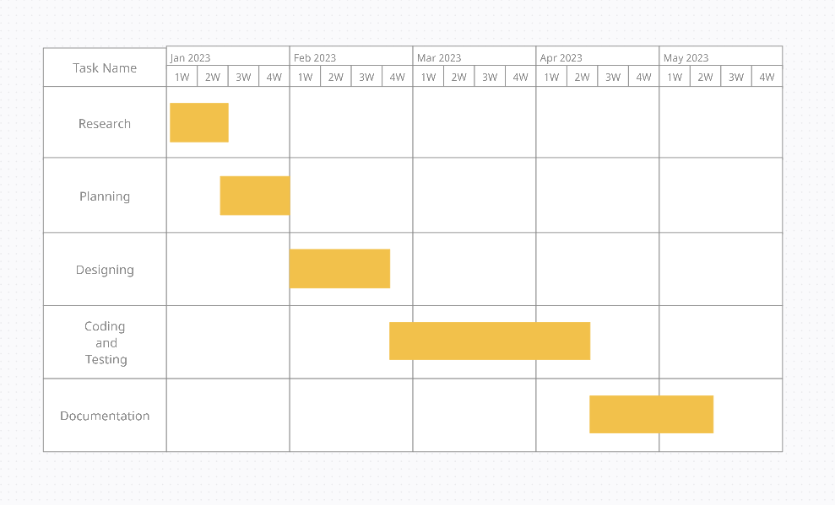

**Figure 3: Gantt Chart for Application Development**

## 3.3. Analysis

Analysis phases include the process by which an individual (s) studies a system such that an information system can be analyzed, modeled, and a logical alternative can be chosen. Systems analysis projects are initiated for three reasons: problems, opportunities, and directions. Analysis is essentially a decision-making process in which analytical tools derived from basic sciences, mathematics, statistics and engineering fundamentals are utilized to develop a product model that can be converted into an actual product.

### 3.3.1. Data Modeling using ER-Diagram

ER-diagram is a visual representation consisting of objects or concepts within the system or database that have attributes and characteristics. Examples in our context includes Items, Customers, Admin, etc. Attributes are the characteristics or properties of the entities. Examples includes Item Price, Item Description, Customer Name, Order ID, Price, etc. Let's have a look at a simple ER diagram of our proposed system to understand this concept.

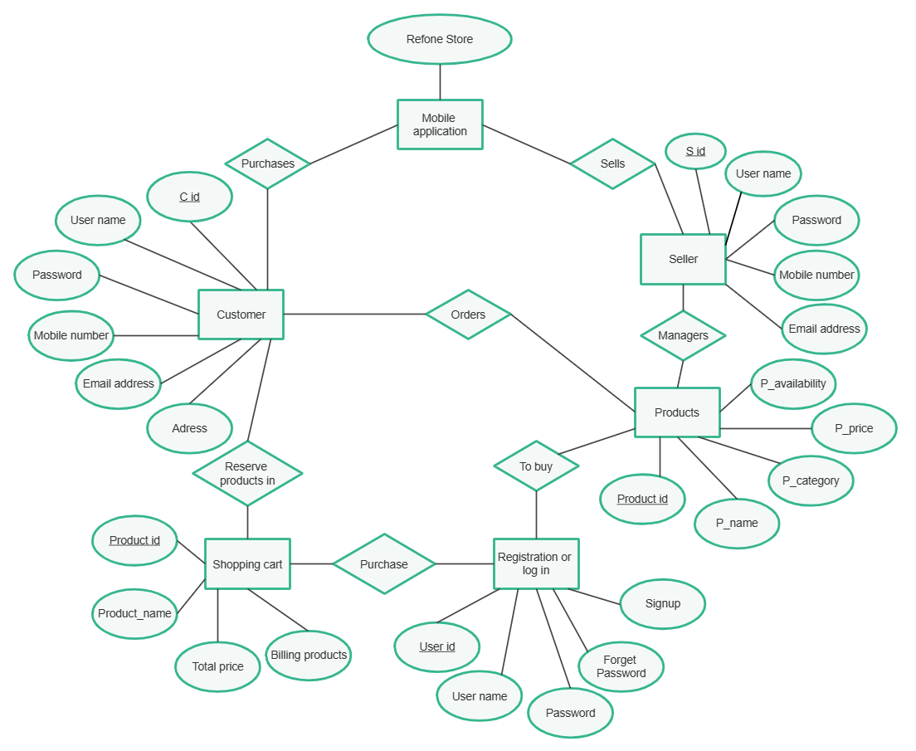

**Figure 4: ER-Diagram**

### 3.3.2. Process Modeling using DFD

DFD graphically represents the functions, or processes, which capture, manipulate, store, and distribute data between a system and its environment and between components of a system. The visual representation makes it a good communication tool between User and System designer. The DFD allows the system to be partitioned into development into independent units so that they, and thereby the system, can be more easily understood.

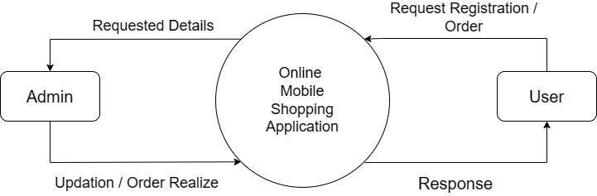

**Figure 5: Level 0 DFD**

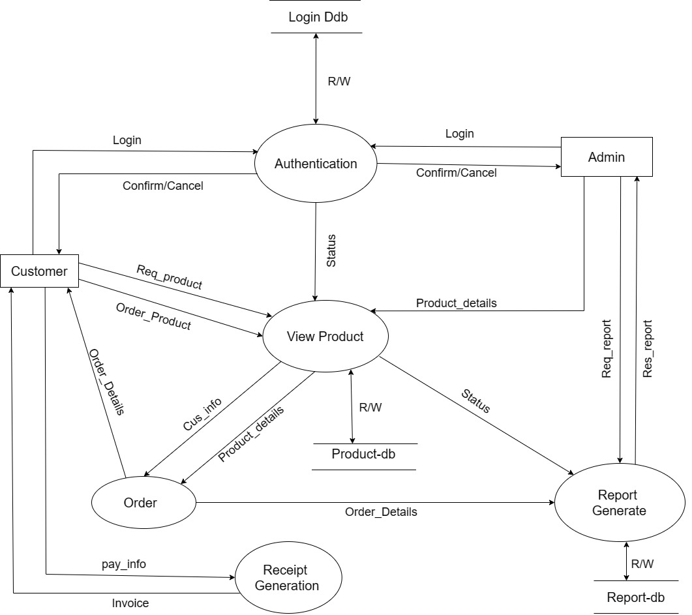

Login db

User

**Figure 6: Level 1 DFD**

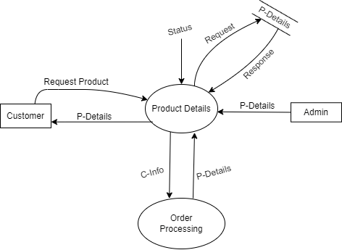

User

**Figure 7: Level 2 DFD (View Products)**

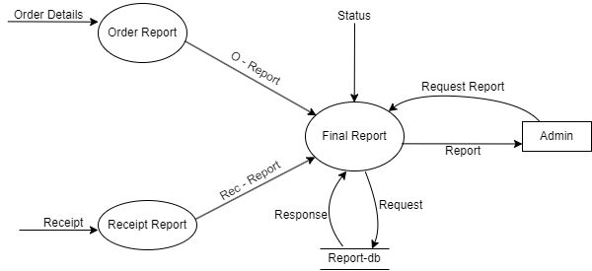

**Figure 8: Level-2 DFD (Report Generate)**

# Chapter 4: System Design

## 4.1. Design

System Design is the process of defining the architecture, components, modules, interfaces and data for a system to satisfy specified requirements. Design of the system brings down the knowledge of requirements and analysis to design the software product. Generally, this chapter deals with the module, database design, user interface design and the program design. For the designing of the application, various diagrams like use case diagram, schema diagram, ER diagram, DFD etc. have been used.

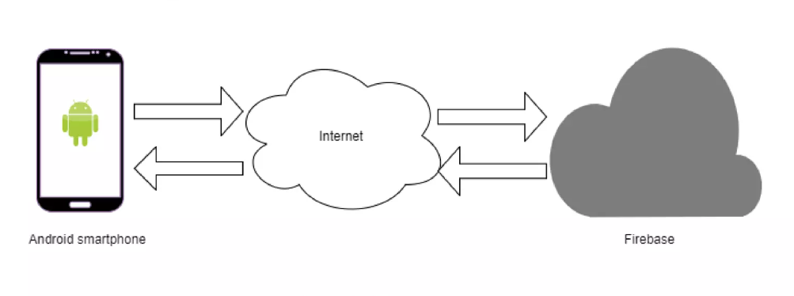

**Figure 9: System Structure of our Application**

The above figure shows the general structure of application connection with the google based cloud service “firebase” in the presence of internet connection.

In the process of creating any mobile application, it was made sure every component is well-built. Even the smallest problems that may arise in the process of creating a mobile app architecture can undermine the quality of the final result. This is why every popular Android application has a highly reliable mobile app architecture.

### 4.1.1. Database Design

Database design is the process of producing a detailed data model of database. This data model contains all the needed logical and physical design choices and physical storage parameters needed to generate a design in a data definition language, which can then be used to create a database.

Here we have transformed our Entity-Relation model into normalized form or a relation database schema. The relational schema is shown in the figure below.

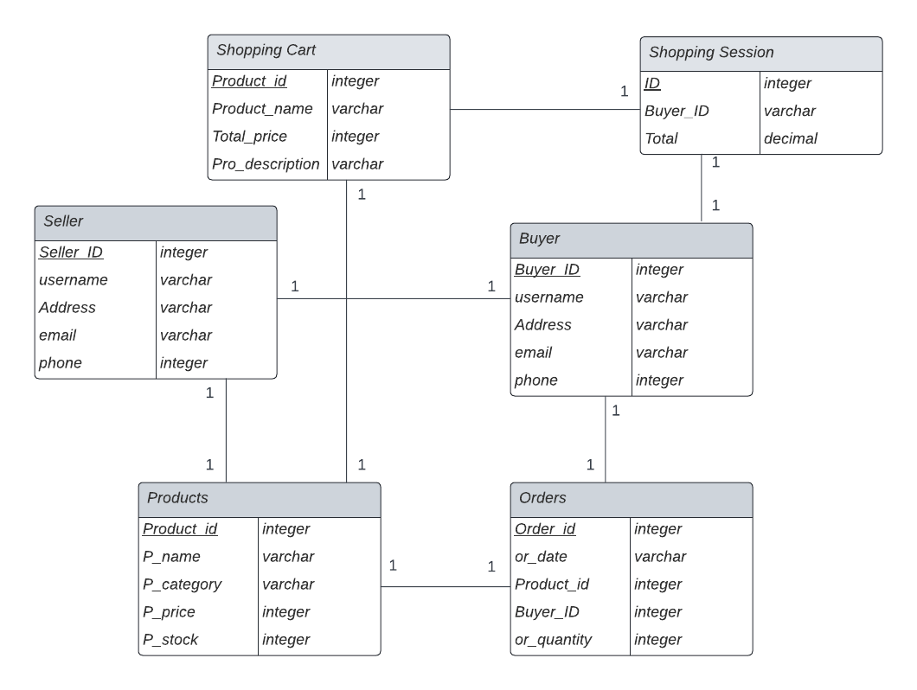

**Figure 10: Database Schema Diagram**

### 4.1.2. Interface and Dialogue Design

The basic interface of our system is of simple design for now in order to demonstrate the system at a different level so that the interface would not be a hindrance to the demonstration. But its scope in the future is very vast so the design of our UI can be made better using various UI designing tools and templates. But for now, we are using a simple interface and dialogue design to understand the system in an easier way and to reduce the production time as well as budget.

### 4.1.3. Form and Report Design

Form and report design are important aspects of user interface design for an application. Forms are used to input data into the system, while reports are used to display or print data from the system.

When designing forms, it is important to consider the usability and accessibility of the form. The form was designed in a way that was easy for the user to understand and use. This was achieved by using clear labels for fields, grouping related fields together, and providing appropriate instructions or help text where necessary.

Report design should also consider usability and accessibility. Reports should be easy to read and understand, and should present information in a clear and organized manner. This can be achieved by using appropriate fonts, colors, and spacing, as well as by organizing information into tables, graphs, or charts where appropriate.

## 4.2. Algorithm Details

**Search Algorithm**: When a user wants to search for smartphones based on certain criteria (e.g., name, price), you can use algorithms like linear search or binary search to efficiently find the matching books in the database.

**Sorting Algorithm**: Sorting algorithms are useful for displaying products in a specific order, such as sorting them by price, brand name, or stock quantity. Common sorting algorithms include bubble sort, insertion sort, merge sort, and quicksort. The choice of algorithm depends on the quantity of smartphones and the desired performance.

# Chapter 5: Implementation and Testing

Systems implementation is the process of defining how the information system should be built (i.e., physical system design), ensuring that the information system is operational and used, ensuring that the information system meets quality standards (i.e., quality assurance). On the other hand, System testing, also referred to as system-level tests or system-integration testing, is the process in which a quality assurance (QA) team evaluates how the various components of an application interact together in the full, integrated system or application. In this chapter we will go through all the implementation tools, use cases and testing phase that went through our proposed system.

## 5.1. Implementation

The implementation phase of the software development refers to the final process of moving the solution from development status. In this phase, Project developers began building and coding the software. This phase is followed by the software development life cycle model used, tools used and the description of major classes/methods.

### 5.1.1. Tools Used

#### 5.1.1.1. Creately

Creately is a visual collaboration platform designed for teams to ideate, plan and execute their work. This platform is mostly known for creating flowcharts, organizational charts, UML diagrams, ER-diagrams, mind maps, Use-case diagrams and many other business visuals. The diagrams used in the above chapters are all drawn using this platform [4].

#### 5.1.1.2. Android Studio 2022.2.1.19 (IDE)

Android Studio is an official integrated development environment specially designed for the development of the android application based on the JetBrains’ IntelliJ IDEA software. The android studio contains all the required functionality and tools required to create, compile, debug and deploy android applications.

All the coding, designing and testing part of the application is done through android studio version 2022.2.

### 5.1.2. Technology Used

#### 5.1.2.1. Kotlin

Kotlin is a modern, statically-typed programming language that was designed to be a better alternative to Java for modern app development. It was first introduced by JetBrains, the company behind the popular IntelliJ IDEA integrated development environment (IDE), in 2011 [5].

#### 5.1.2.2 XML

XML stands for Extensible Markup Language that was used in this project to display and manage the GUI components. All the layout of the project were defined by the XML. Besides these, defining the animation, color, style, string, dimension, menu, etc. have also been done using XML. Similarly, the configuration files are based on XML. The layout is created and described in XML because by storing the user interface as XML file, it is easier to parse and the existing code refactor tools can work without any changes. The xml file is described inside android Studio IDE.

#### 5.1.2.3 Firebase

Firebase is a google based cloud service that permits you to make applications with no server-side programming so that development turns out to be quicker and easier. This application has used Firebase API to connect with the firebase. Firebase has used mainly to provide email authentication and real time database in the application. This application has used Firebase email and password-based authentication method to let users authenticate with Firebase using their email and passwords, and manage their accounts. In addition to this, sending mail for the confirmation of account registration and sending password reset email has also been done by the use of firebase authentication [6].

#### 5.1.2.4. Git

Git was used as a distributed version control system designed to track changes in source code during software development. It also provided features like tagging and reverting changes to previous versions of code if we didn’t like the newer versions.

For version control and change tracking we will be using git along with GitHub. This ensures coordination among the programming members during app development.

### 5.1.3. Database

To store data of Users, Smartphones, and other information SQLite database is used. SQLite is an open-source database that helps to interact with relational databases. SQLite is stored as a single file. This makes sharing databases easier. By default, Django uses the SQLite database. The basic working principle of **Refone Store** Application can be illustrated by the following block diagram:

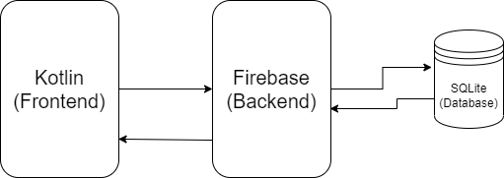

**Figure 11: Block Diagram of this application with database**

### 5.1.5. Implementation Details of Modules

Modules should be specified and designed so that information (procedure and data) contained within a module is inaccessible to other modules that have no need for such information. The implementation details of the modules include the following:

* Design the wireframe of the application.
* Data modelling.
* Training the data.
* Code the front-end of the app in Kotlin.
* Link the application with the server side
* Finally, test, debug and implement the application.

## 5.2. Testing

System Testing was performed whose primary purpose is to fully exercise the computer-based system. Although each test has a different purpose, all work to verify that all the system elements have been properly integrated and performed allocated functions. The testing process was carried out to make sure that the product exactly does the same thing that it was supposed to do. Testing is the final verification and validation activity for our application.

There are two types of testing: Unit Testing and System Testing

### 5.2.1. Unit Testing

Unit testing is a software testing method by which individual units of source code, sets of one or more computer modules together with associated control data, usage procedures, and operating procedures, are tested to determine whether they are fit for use. In this system, the individual units are individually tested by providing one or few inputs and expected for the single output.

**Table 1: Testing Registration System (Case-1)**

|  |  |
| --- | --- |
| Test Case | 1 |
| Action | Testing Registration System  First Name: Samundra  Last Name: Khanal  Email: samundrakhanal  Password: 123456789 |
| Expected Result | It was expected that if the user enters invalid details such as the email above, error message is displayed which also includes leaving the text fields empty. |
| Actual Result | From this test, we can find that error messages is displayed when entering invalid details which makes unable to log into the system. |
| Test Result | Registration was unsuccessful |

**Table 2: Testing Registration System (Case-2)**

|  |  |
| --- | --- |
| Test Case | 2 |
| Action | Testing Registration System  First Name: Samundra  Last Name: Khanal  Email: aaerik534@gmail.com  Password: 123456789 |
| Expected Result | It was expected that after entering the valid details user must be able to register in the application. |
| Actual Result | The user was directed to the login page after registration |
| Test Result | Registration was successful. |

**Table 3: Testing Login System (Case-1)**

|  |  |
| --- | --- |
| Test Case | 1 |
| Action | Testing Login System  Email: aaerik534@gmail.com  Password: khanal12 |
| Expected Result | It was expected that after entering the wrong password the user won’t be able to login to the application |
| Actual Result | From this test, we can find that error message is displayed when entering invalid details which makes unable to log into the system. |
| Test Result | Login to the system was unsuccessful |

**Table 4: Testing Login System (Case-2)**

|  |  |
| --- | --- |
| Test Case | 2 |
| Action | Testing Login System  Email: aaerik534@gmail.com  Password: khanal123samu |
| Expected Result | It was expected that after entering the valid details user must be able to log in into the application. |
| Actual Result | The user was directed to the dashboard after login success. |
| Test Result | Login to the system was successful. |

**Table 5: Testing Search Products**

|  |  |
| --- | --- |
| Test | 3 |
| Action | Testing search products in customer dashboard. |
| Expected Result | It was expected that customer can enter the required product by their name in search box, which would display the searched product. |
| Actual Result | From this test, we can find that the product searched by its name is displayed. |
| Test Result | Searching products was successful. |

**Table 6: Testing Filter Products**

|  |  |
| --- | --- |
| Test | 4 |
| Action | Testing Filter Products. |
| Expected Result | It was expected that user can filter the products in dashboard page based on price. Customer can also sort the products based on newest, low to high price and high to low price. |
| Actual Result | From this test, we can find that customers will be able to filter the products accordingly to their desire. |
| Test Result | Filtering products was successful. |

**Table 7: Testing to add Products in Cart List**

|  |  |
| --- | --- |
| Test | 5 |
| Action | Testing to add product in Cart List. |
| Expected Result | It was expected that customer can add products as they desired in Cart list page and can also add product to the cart from Cart list page. |
| Actual Result | From this test, we can find that the product products can be added to wish list page and that product can be also added to the cart from Cart list page. |
| Test Result | Test was successful. |

**Table 8: Testing to Manage Order Details**

|  |  |
| --- | --- |
| Test | 6 |
| Action | Managing customer order details. |
| Expected Result | It was expected that all the orders details of the customers can be viewed and the order status will be changed successfully. |
| Actual Result | From this test, we can find that the order status can be changes from admin dashboard. |
| Test Result | Managing customer order details was successfully performed. |

**Table 9: Testing Reset Password**

|  |  |
| --- | --- |
| Test | 7 |
| Action | Testing Reset Password. |
| Expected Result | It was expected that when the user forgets the password of his/her id they must be able to reset it. |
| Actual Result | Clicking on the reset password button user will have to enter the email to which the password reset link will be sent. Using those link the user was able to change his/her password. |
| Test Result | Password Reset was successfully. |

### 5.2.2. System Testing:

System testing is done to validate and verify the overall functionality of the project. Likewise, after the completion of the development phase and unit testing along with the integration, module and acceptance testing, our team did the system testing. The overall summary of whether the product is fully integrated or not is shown by the table below.

**Table 10: System Testing**

|  |  |
| --- | --- |
| **Testing Phase** | **Objectives** |
| Unit Testing | We did the unit testing of almost each and every function of code and provided the information of unit testing in the above table. |
| Module Testing | This testing was composed of the testing of various program related modules. It was performed to check the module functionality and interaction between units and within a module. |
| Integration testing | After testing each and every code along with the modules we performed the integration testing and checked the behavior of integrating the two or more modules in the system (during the connection of frontend, backend and database). |
| Acceptance testing | Lastly after all the testing we check whether the product is built as per our requirement and strategy and we accept the final product. |

## 5.3. Result Analysis

So far we are concerned, we have seen through the various aspects of our project, what consequences we face, what algorithm we used, what methodology we used, what we concluded from the testing and so on. So, we saw full SDLC phases in this project so now let's see what result we got and what problem we faced in this topic.

### 5.3.1. Challenges Faced:

Every project comes with its own set of challenges, and it's no different for my project. Some of the challenges that I have faced so far include managing time effectively, coordinating with team members who have different schedules and priorities, and ensuring that everyone is on the same page in terms of project goals and expectations. Additionally, communication has been a key challenge, as we are all working remotely and rely heavily on digital communication tools. It's important to stay organized and adaptable in the face of these challenges, and to remain focused on the ultimate goal of delivering a high-quality project that meets the needs of our stakeholders. The major challenges we faced during the duration of our project can be divided into two subsections.

## 5.4. Significant Features

Exclusive of all the challenges faced, “**Refone Store**” has come out with following significant features overcoming all the challenges. Some of the important features are:

**Search**: The application includes a powerful search function that allows to find products quickly and easily. User can search by smartphone names.

**Active 24/7**: This application utilizes a highly reliable and scalable database system that ensures maximum uptime and availability.

**Slide Show**: The application includes a dynamic slideshow on the dashboard to highlight the latest and important discounts on different smartphones along with their time validity.

**Add and View products**: Users can also add a new product and view them within the same app, making it a convenient and efficient tool for managing their inventory.

# Chapter 6: Conclusion and Future Recommendations

## 6.1. Conclusion

This project is an application specifically designed for consumers who wishes to purchase second-hand smartphones by staying at home and would also be proven beneficial in the near future for user. With the help of this application, people who can’t find time to visit the market because of the work and other house matters can easily buy smartphones online easily and have them delivered in the given location. This application provides many facilities like Cart which allows them to add the selected smartphones to their cart, search engine for searching for a certain smartphone brand or model, viewing products based on their categories and others. This application will be very convenient for customers and admins as customers can purchase smartphone online and admin can use this application for adding or deleting the phones, manage delivery, check user profile and so. After studying different methodologies for finding the suitable one for this project, Waterfall Model was used in the method process because of its efficiency and features. In order to gather information regarding the user requirements, online survey was also done and the collected information was analyzed and performed in the system. Data from different research paper was collected and along with websites. Research was done on many applications similar to the project to collect some idea relating the project.

This project was completed with the guidelines provided by supervisors, which would have not been successful without them. Information gathered from the people relating the project along with the research made the completion of this project possible.

## 6.2. Future Work:

The proposed system that has been developed was done under the constraint of time which led to limitations in some of the features of the system. With the proposed system being used for the future, there is bound to be feedbacks and maintenances in the system which would include the future enhancements in the system. Though the project contains all the necessary feature of an e-commerce application, there are still some featured need to be added. A good online smartphone buying application means easy and satisfying platform for the user to purchase the smartphones as they need. The following are some of the features that will be added in the future updates of our application:

* The application will be made cross-platform.
* The notification system will be added in our application so as to notify if any new smartphone has been added to the dashboard by the seller.
* Support for multiple languages will be made available.
* An easier medium of payment for local customers would also be included i.e. payment using digital wallet such as Khalti, Esewa.

# References

|  |  |
| --- | --- |
| [1] | "Research Archieves | SellCell," SellCell, 2008. [Online]. Available: https://www.sellcell.com/blog/category/research/. [Accessed March 2023]. |
| [2] | "University of Cambridge," Cambridge University, 1209. [Online]. Available: https://www.cam.ac.uk/. [Accessed Jan 2023]. |
| [3] | D. B. Rembiesa, "IAITAM Home - IAITAM," 2002. [Online]. Available: https://iaitam.org/. [Accessed Feb 2023]. |
| [4] | N. F. a. C. Jayasundara, "Gantt Chart | Creatly," Cinergix, 2008. [Online]. Available: https://app.creately.com/d/fHWbmHKw5sT/view. [Accessed Feb 2023]. |
| [5] | Kotlin, "Kotlin Docs," JetBrains, 2011. [Online]. Available: https://kotlinlang.org/docs/home.html. [Accessed 20 November 2022]. |
| [6] | A. L. a. J. Tamplin, "Firebase," Google, 10 2014. [Online]. Available: https://firebase.google.com/. [Accessed Jan 2023]. |

‌

# 

# APPENDIX

|  |  |
| --- | --- |
| **Figure 12: App Splash Page** | **Figure 13: Create an Account Page** |

|  |  |
| --- | --- |
| **Figure 14: Login Page** | **Figure 15: Forgot Password Page** |

|  |  |
| --- | --- |
| **Figure 16: Dashboard Page** | **Figure 17: Products Detail Page** |

|  |  |
| --- | --- |
| **Figure 18: Product Search Page** | **Figure 19: My Products Page** |

|  |  |
| --- | --- |
| **Figure 20: Add Products Page** | **Figure 21: My Orders Page (Bought)** |

|  |  |
| --- | --- |
| **Figure 22: My Order Details Page (Seller)** | **Figure 23: Sold Products Page (Seller)** |

|  |  |
| --- | --- |
| **Figure 24: Sold Product Details Page (Seller)** | **Figure 25: Sold Products Page (Seller)** |

|  |  |
| --- | --- |
| **Figure 26: User Account Page** | **Figure 27: Edit Profile Page** |

|  |  |
| --- | --- |
| **Figure 28: Product Details Page (Buyer)** | **Figure 29: My Cart Page (Buyer)** |

|  |  |
| --- | --- |
| **Figure 30: Add Address Page (Buyer)** | **Figure 31: Checkout Page (Buyer)** |